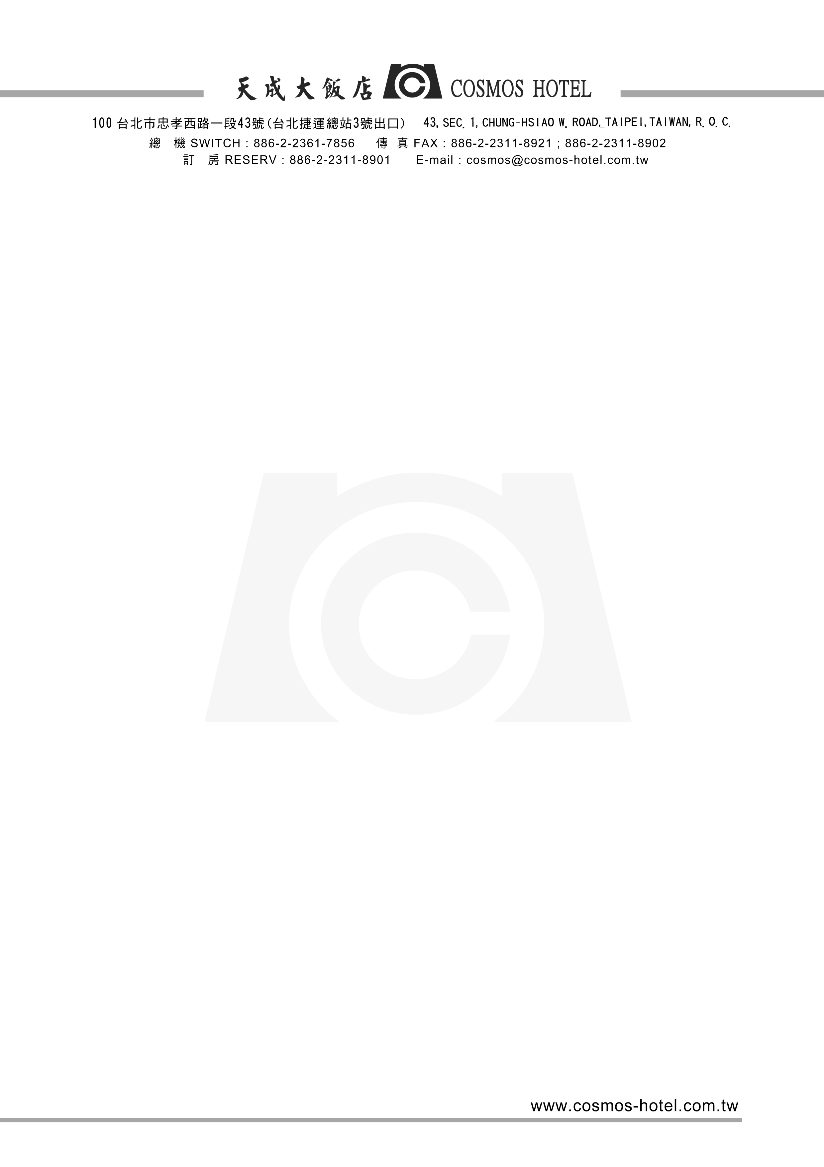

APNOMS 2011 Sep.21~Sep.23
Reservation Form (Reservation Deadline: 2011 Sep.07)
.
Customer Information：
Last Name： First Name：
Chinese Name（IF ANY）： Title：□Mr. □Ms.
TEL： FAX：
E-mail： Passport Number：
Accompanying Person：Last Name and First Name：
Flight ＆ Accommodation Information：
Check In Date：______ / ______ / _______ (dd/mm/yy)
Check In Time：______ / ______/ _______ (dd/mm/yy)
Room Types：
- Superior Twin Room  （2 single beds for 2 Persons）  NT＄3,600×___ Room(s) | - Superior Single Room  （1 double bed for 1 Person）  NT＄3,200×___Room(s)
- Superior Double Room  （1 double bed for 2 Persons）  NT＄3,400×___ Room(s) | The above room rates are inclusive daily breakfast 、  10% service charge and a 5% government tax  Free ADSL in room
Airport Pick up Service：□ Limo NT$1,300 / per car / per trip
□Van( 9 Person )NT$2,000 / per van / per trip
NOTE：
- Hotel rates/The foreign exchange rate will be calculated according to the payment date rate.
- Payment: The foreign exchange rate and 10 % of service charge will be included in your payment.
- Cosmos Hotel provides buffet breakfast, and daily newspaper.

Other Request：
Method of Payment：
□Visa □Master □JCB □AE
Card Number：_____________________Card Holder’s Name：_________________
Expiry Date：____________ Signature：________________
@ Please noted that your credit card number is only for reservation purpose and will not charge you any fee if the room is available on the dates you request.
@ Cancellation Policy： Reservations cancelled less than 24 hours prior to the day of arrival will be subject to a one-night charge.
@All reservation requests must be sent to Cosmos hotel via fax, phone or e-mail:
Fax : +886 2 2311 8902 / Phone : +886 2 2311 8905 #226,
E-Mail: cosmos@cosmos-hotel.com.tw attention to Sales Dept., Miss Milly Huang

