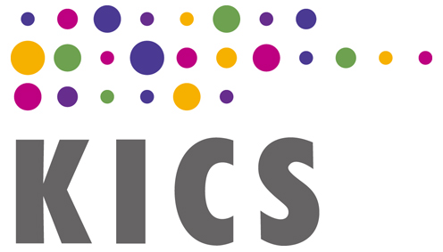
The Korean Institute of Communications and Information Sciences

INVOICE

The 17th Asia-Pacific Network Operations and Management Symposium
The Korean Institute of Communications and Inforamtion Sciences (KICS)
#1504-6, 42, Seocho-daero 78 gil, Seocho-gu

Seoul 137-858, Korea

Name :
Registration No :

Attendee/Type | Early-Bird/Presenters  (by Jul. 24, 2017) | Advance  (by Aug. 16, 2017) | Late/Onsite  (after Aug. 16, 2017)
Full | 500,000 KRW | 550,000 KRW | 600,000 KRW
Student | 170,000 KRW | 210,000 KRW | 250,000 KRW
Exhibitor | 190,000 KRW | 280,000 KRW | 380,000 KRW
Extra Banquet  Tiket | 70,000 KRW | 70,000 KRW | 70,000 KRW
Extra  Proceedings | 45,000 KRW | 45,000 KRW | 45,000 KRW

Method of Payment

Payment Amount $

□ Online Credit Card Payment
- Credit Card Payment System (VISA, MasterCard, JCB)
The online registration system uses the Samsung ALLatPay electronic payment subsystem. At the very beginning, users have to download and install “AllatPayPluginEn.exe” or “AllatPayPlugin.exe” on their own computers for later online payment. After installing the *.exe file, users have to let the online payment window pop up and then enter credit card info. Finally, users can complete the card payment transaction by clicking the “submit” button.

□ Credit Card Payment by E-Mail
– You may want to pay registration fee by credit card, but not to use online payment system due to security concern.
– In this case, please use a hard copy registration form ( Word, PDF).
– Please complete the form to provide registration and credit card information.
– Scan the completed form in order to make a PDF or image file of it.
– And then, send it to Prof. Mi-Jung Choi via E-Mail(mjchoi(at)kangwon.ac.kr)
– Please do not forget online registration first before above steps.
□ Bank Transfer
* For USD (United States Dollar) or KRW (Korean Won) transfer
– Name of Bank: Woori Bank, Seoul, Korea
– Account No.: 133-118981-13-120
– Account Holder: Korea Information and Communication Society (KICS)
– Address of Bank : 1-203, Hoehyeon-dong, Jung-gu, Seoul, Korea
– Swift Code: HVBKKRSE
– All bank service charges for bank transfer must be paid by the registrants. Please email us a copy of the remittance statement to us along with this registration form(English: Word, PDF)
– E-Mail: mjchoi(at)kangwon.ac.kr

Jong-Seon No, President
The Korean Institute of Communications and Information Sciences

